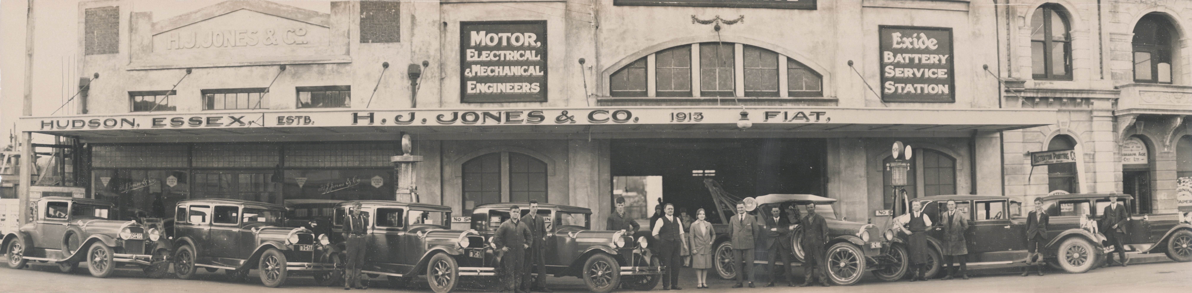

29 Hudson Coupe 2 x 29 Essex Town Sedans 29 Essex Coach 1920 Hudson Tow Truck 28 Hudson Landau, 29 Essex 4 Dr Sedan

L-R Unknown person, Gordon Jones, Noel Dorset, Doug Cameron, Fred Holloway, Reenie Jones, Herb Jones, Ted D’Isle, Bob Rawcliffe, Age (Office employee), Ernie Cambourne (foreman), Les Jones, Unknown person.
Approx 1930 Masterton NZ

