Storage space was quite good even by today’s standards, due partly to a design which today could be called a modified hatchback; the car looked like a wagon, with no separate trunk, and a very large rear hatch opening with 17 cubic feet of space in the trunk. (If the spare tire was carried inside, that went down to a meager 12.5 feet.) In “trunk models,” cargo space went up to a full 21 feet (16.5 with the spare), good by today's standards. The main difference appears to be a cargo door that bulged outwards rather than a flat door.
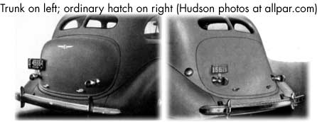Hudson also bragged about their engines, with gas mileage of 18-20 mpg (20.1 mpg in a national economy test), and a built in oil cooler that allowed oil to last longer. Another drivetrain feature was the Electric Hand option, which “shifts gears at finger touch.” The Hudson apparently set economy records at Bonneville Salt Flats, and, according to the company, was used extensively by law enforcement.

